NAME: WEEK 2: 4/27 – 5/1
4/27
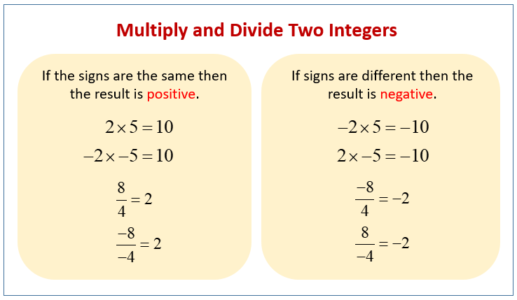
1. -1 × -6 = 2. -7 × 7 = 3. 5 × -7 = 4. -2 × -2 = 5. -8 × 3 = 6. 4 × 8 = 7. -1 × 6 = 8. -6 × 4 = 9. -8 × -7 = 10. -6 × 7 = 11. -4 × -1 = 12. -7 × -7 = 13. -6 × 5 = 14. -2 × -3 = 15. 4 × 2 = 16. -6 × -9 = 17. -4 × -3 = 18. -9 × -5 =
4/28
MULTIPLYING INTEGERS
(−6)×0 = 7×3 = 6×(−10) = (−3)×(−5) = 8×(−2) = (−4)×(−10) = 10×(−3) = 3×5 = 9×(−4) = 10×4 = 10×(−4) = 5×9 = 0×(−10) = 11×11 = 2×3 = (−4)×(−12) = (−4)×(−6) = (−10)×(−2) = 3×12 = 4×7 = 2×4 = 3×(−3) = (−12)×(−12) = (−9)×5 = 9×(−7) = 9×8 = (−1)×10 = (−1)×(−2) = 4×(−12) = (−6)×(−5) =
4/29
1. -176 ÷ 11 = 2. -190 ÷ 2 = 3. 33 ÷ 11 = 4. 4 ÷ 4 = 5. 54 ÷ 2 = 6. -10 ÷ -10 = 7. -60 ÷ -12 = 8. 15 ÷ -5 = 9. 60 ÷ -10 = 10. 168 ÷ 7 = 11. 60 ÷ -12 = 12. 88 ÷ -8 = 13. 24 ÷ 12 = 14. 110 ÷ -11 = 15. -108 ÷ -3 =
4/30
DIVIDING INTEGERS
1. 130 ÷ -10 = 2. 16 ÷ -4 = 3. -3 ÷ -3 = 4. 72 ÷ 4 = 5. 142 ÷ -2 = 6. -114 ÷ -2 = 7. -99 ÷ 3 = 8. -180 ÷ -4 = 9. -160 ÷ -4 = 10. 10 ÷ -10 = 11. 4 ÷ 1 = 12. -120 ÷ -4 = 13. 33 ÷ -11 = 14. 1,000 ÷ -10 = 15. 120 ÷ -12 = 16. -161 ÷ -7 = 17. 77 ÷ -7 = 18. -72 ÷ 12 = 19. -77 ÷ 11 = 20. -44 ÷ 11 = 21. -60 ÷ -10 =

5/1
ALL OPERATIONS INTEGERS REVIEW
(-5) + (-4) = (-4) × (-7) = (+6) - (-2) = (-3) + (+1) = (-18) ÷ (-6) = (-1) × (+5) = (-2) × (-7) = (+8) × (+3) = (+9) + (-3) =
(+3) × (-1) = (-4) - (-1) = (+6) + (-5) = (-3) + (+9) = (-5) × (+3) = (-3) ÷ (+3) = (-3) × (+3) = (-3) + (-6) = (+8) + (-9) = (-5) × (+5) (-8) - (+6) (-7) - (-3) = (+1) - (-9) = (+8) × (+4) = (-4) + (-5) = (+8) - (-2) = (-9) + (-4) = (6) × (+3) =
(-7) - (+2) = (+2) × (-4) = (+3) + (-8) =

