**NAME: WEEK 4: 5/18 – 5/22**

5/18

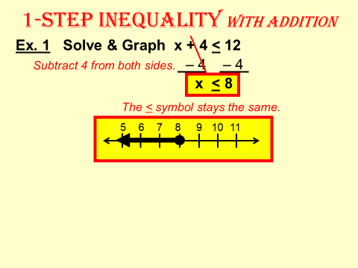

1.  2. 

3.  4. 

5.  6. 

7.  8. 

**5/19**

REVIEW SOLVING ALGEBRAIC INEQUALITIES:

1.  2. 

3.  4. 

5.  6. 

A.  B. 

C.  D. 

E.  F. 

G.  H. 

**5/20**

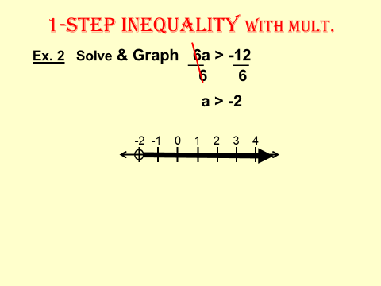

1.  2. 

3.  4. 

5.  6.

7.  8. 

**5/21**

REVIEW SOLVING ALGEBRAIC INEQUALITIES:

1.  2.

3. 4.

5.  6. 

7.  8.

9.  10.

11. 12. 